Hiep Ha

CS-499

Professor Joseph Martinez

Oct. 5, 2025

5-2 Milestone Four: Enhancement Three: Databases

For my third enhancement, I chose the same Android Inventory Management application that I used in the previous milestones. This project began earlier in my computer science program and was built to help users manage products in a local SQLite database. The application allows users to add, edit, delete, and search for items in their inventory through a simple Android interface. I selected this artifact for my database enhancement because it directly represents my ability to design, manage, and improve database systems inside a real working application.

The main improvement in this enhancement focused on the database structure and interaction logic. I added a **transactions** table and created **triggers** that automatically record every insert, **update**, and **delete** made in the inventory table. This allows the system to track changes for auditing and reporting purposes. I also built a **View Log** feature that reads from the transactions table and displays the change history to the user. This helps users understand what items were modified and when. I also improved the **data export** system, changing it from an internal file save to a public **Downloads folder export**, which makes it easier for users to retrieve their exported CSV reports directly on their device. These changes demonstrate my skills in database normalization, SQL trigger design, and practical Android data persistence.

Through this enhancement, I met my planned outcome of demonstrating strong database design and management skills. I created tables with relational integrity and foreign keys, wrote efficient SQL queries for reading and writing data, and ensured that database triggers work correctly to maintain consistency automatically. I also practiced good transaction management in Java by wrapping multiple insert and update operations in atomic transactions, which improved performance and reduced the chance of data corruption. My outcome coverage plan from earlier modules still applies, as this enhancement successfully completes the database category for my ePortfolio.

While enhancing and testing this artifact, I learned more about how databases behave in mobile environments, especially when managing user permissions and file storage paths. I had to solve several challenges, such as fixing permission errors when exporting data and ensuring that triggers did not create duplicate logs. I also learned the importance of indexing for faster search and how Android’s content resolver can safely write to shared storage locations like the Downloads folder. Overall, this enhancement strengthened my confidence in applying relational database principles in mobile application development. It shows that I can build reliable, user-friendly applications with a solid backend structure that supports real-world use.

|  |  |  |  |
| --- | --- | --- | --- |
| **Checkpoint** | **Software Design and Engineering** | **Algorithms and Data Structures** | **Databases** |
| **Name of Artifact Used** | CS-360 Mobile Application (Inventory App) | CS-360 Mobile Application (Inventory App) | CS-360 Mobile Application (Inventory App) |
| **Status of Initial Enhancement** | Completed in Milestone Two (UI redesign with RecyclerView and input validation) | Completed in Milestone Three (batch insert, cache, DiffUtil, debounce search) | Completed (transaction log, triggers, export) |
| **Submission Status** | Submitted | Submitted | |  | | --- | | Ready for Milestone Four submission |  |  | | --- | |  | |
| **Status of Final Enhancement** | Final version approved | |  | | --- | | Final version approved |  |  | | --- | |  | | Completed and tested on Android device |
| **Uploaded to ePortfolio** | Uploaded | Uploaded | Uploaded |
| **Status of Finalized ePortfolio** | In progress | In progress | In progress |

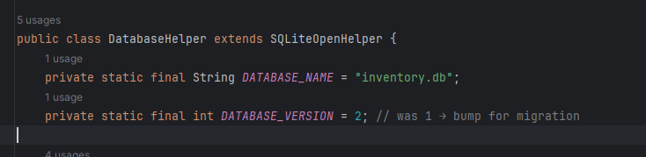

Figure 1. Updated Codes for Module 5

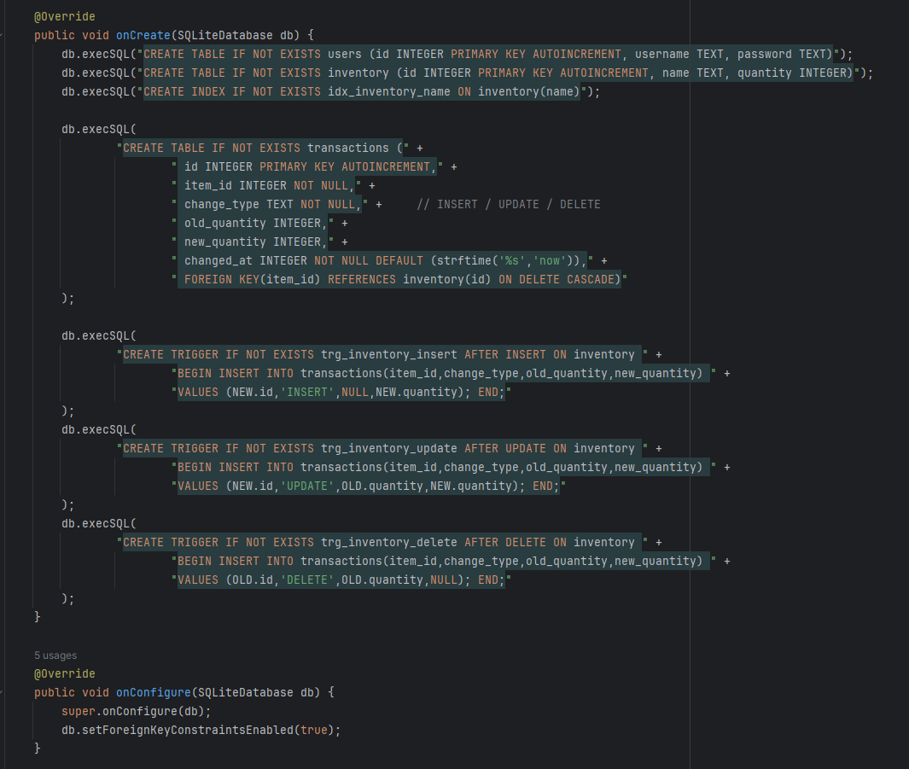

Figure 2. Updated Codes for Module 5

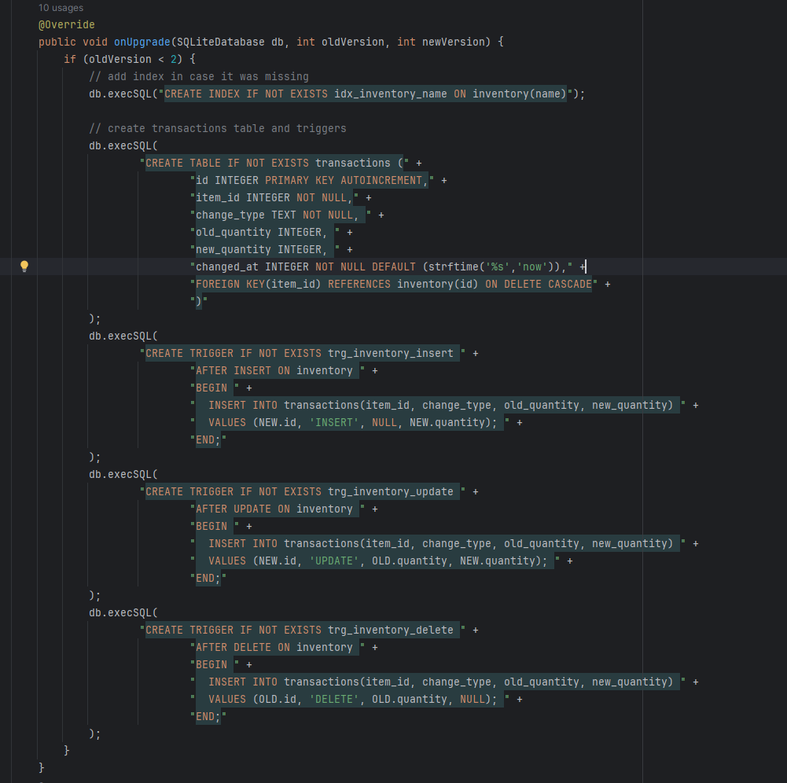

Figure 3. Updated Codes for Module 5

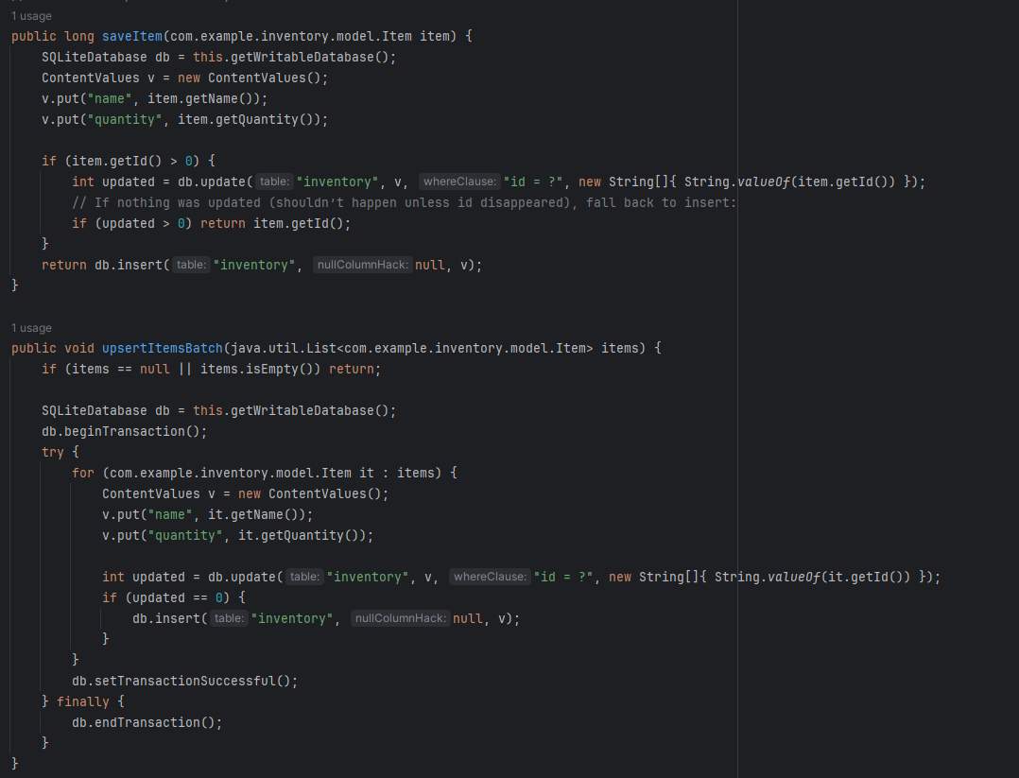

Figure 4. Updated Codes for Module 5

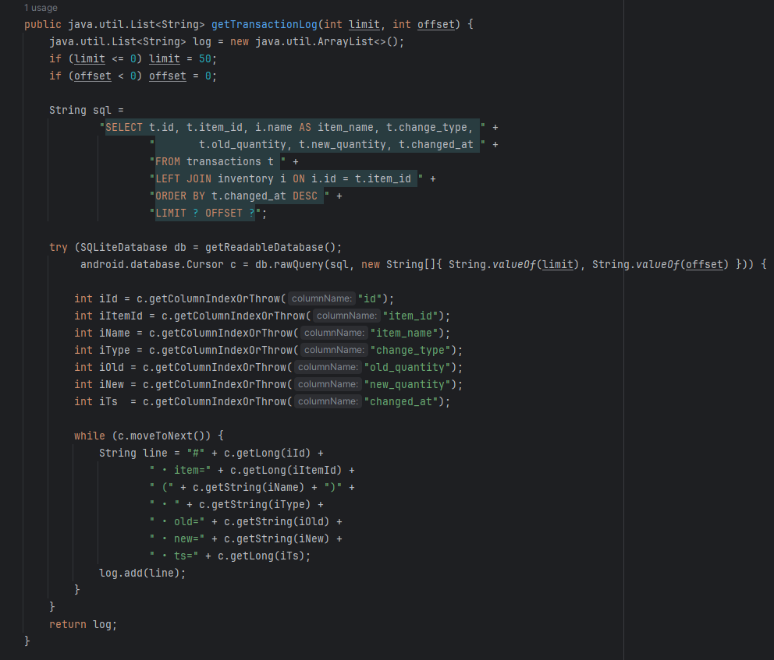

Figure 5. Updated Codes for Module 5

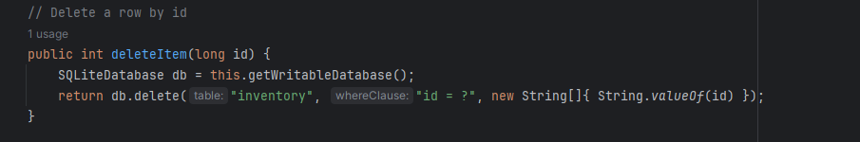

Figure 6. Updated Codes for Module 5

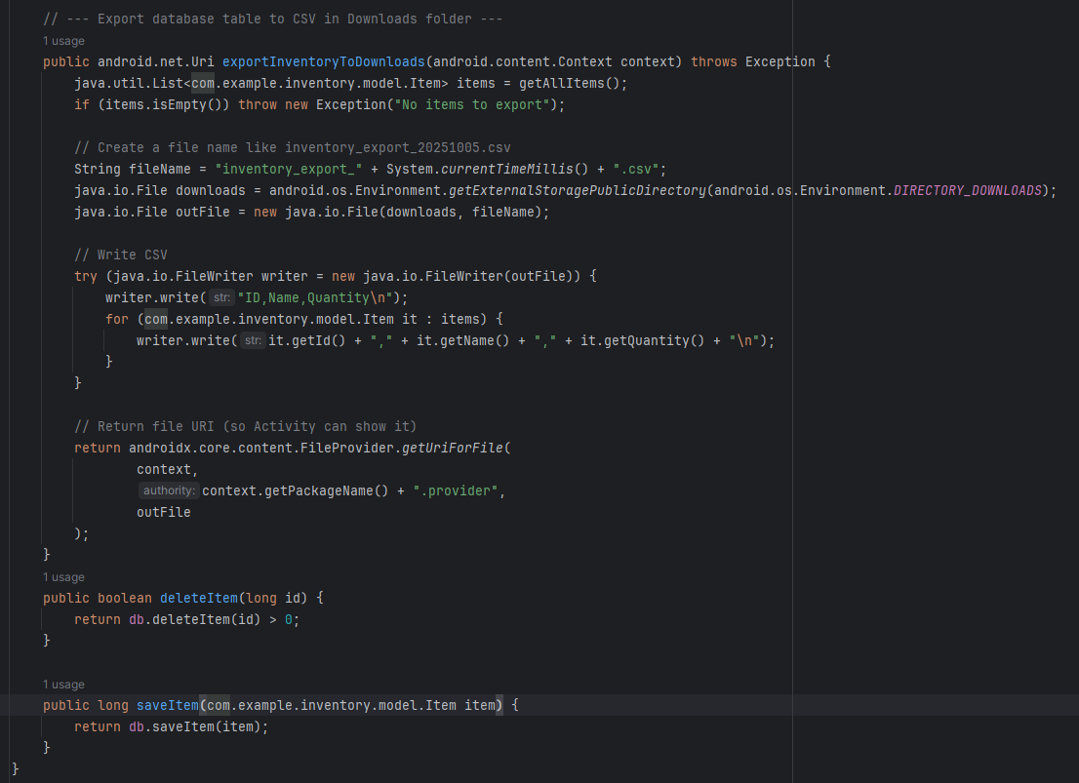

Figure 7. Updated Codes for Module 5

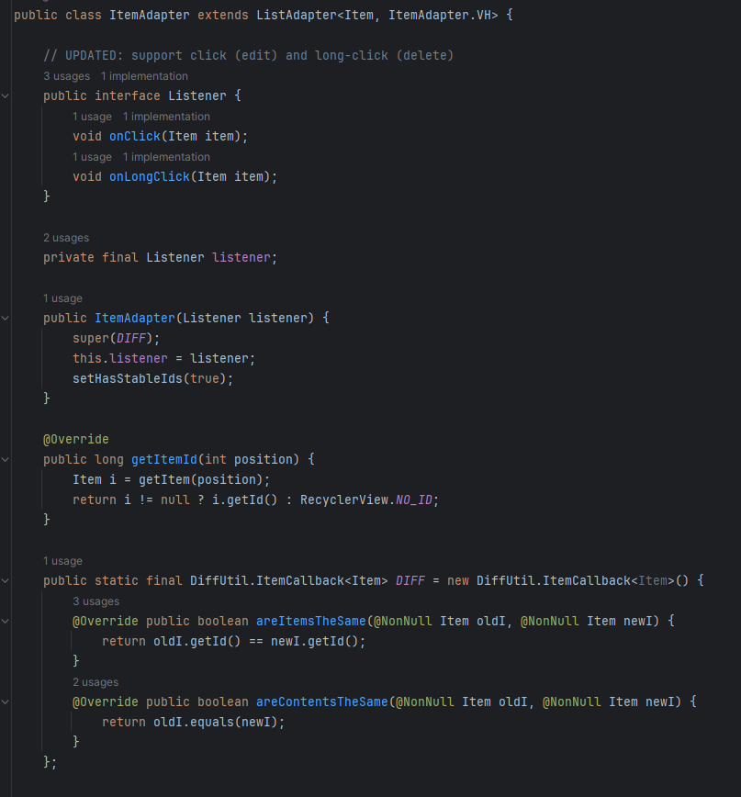

Figure 8. Updated Codes for Module 5

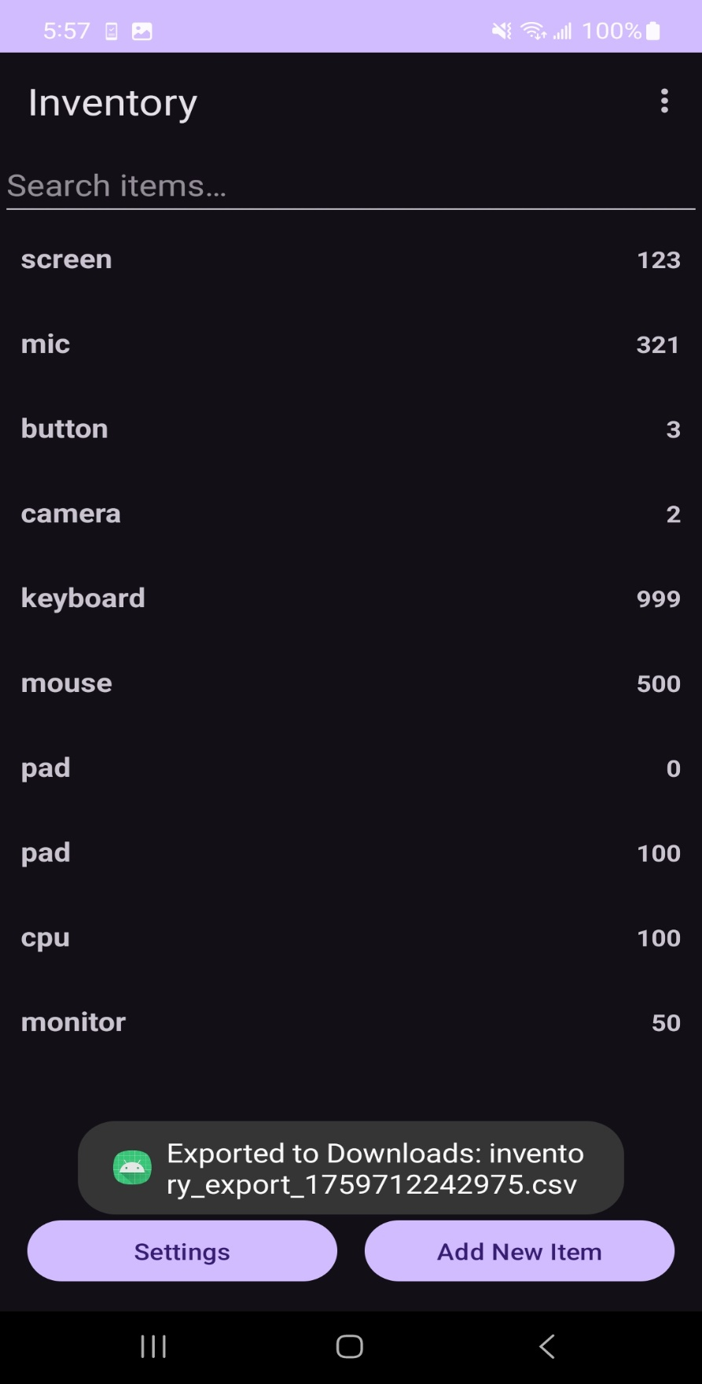

Figure 9. Exported report screenshot

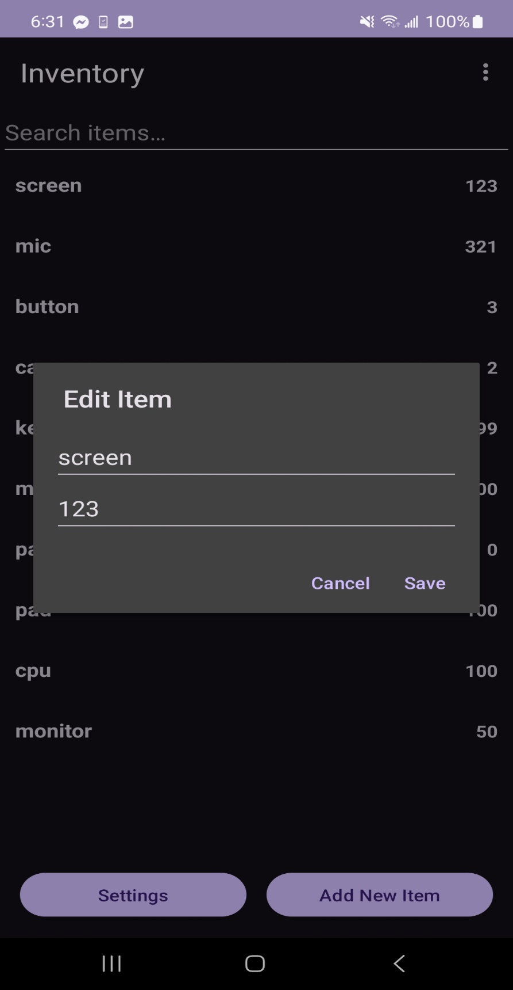

Figure 10. Edit item screenshot

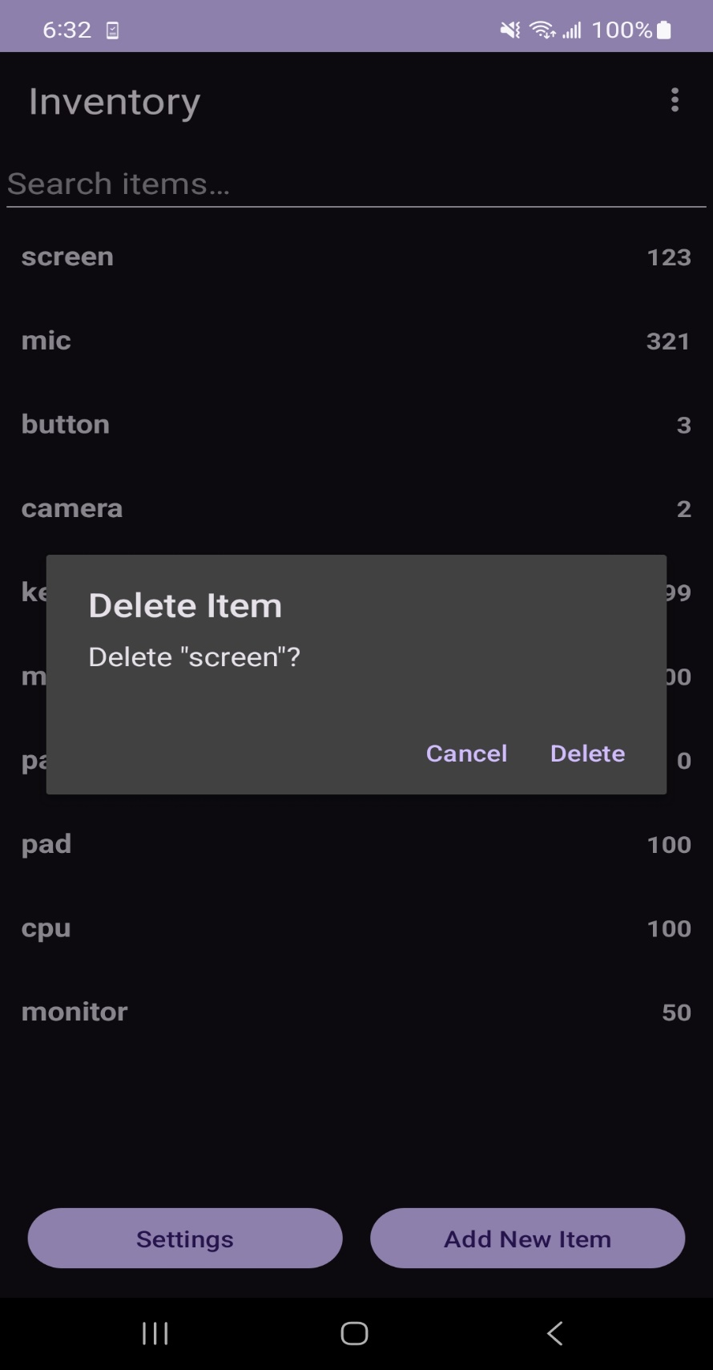

Figure 11. Delete item screenshot